Drug Classification
Today we will cover:
Students understand that drugs are classified based on the effect it has on the body
What is the difference between illicit and illegal drugs
​
Drug Classification
Effects it has on the body
Examples
Street Names

THINK< PAIR< SHARE
​As an individual, then in pairs, and finally as a class make a list in your textbook of legal and illegal drugs. No looking online........

- Suggest reasons why alcohol and tobacco remain as legal drugs, despite being the drugs most responsible for illness and death in Australians.
2) Form pairs and discuss what legalities there are for smoking and alcohol use?

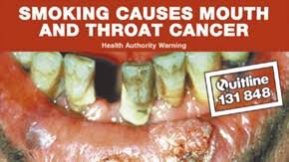
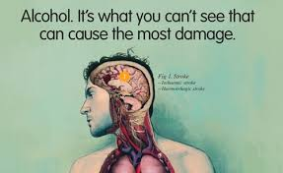

Class Discussion – what do you know?
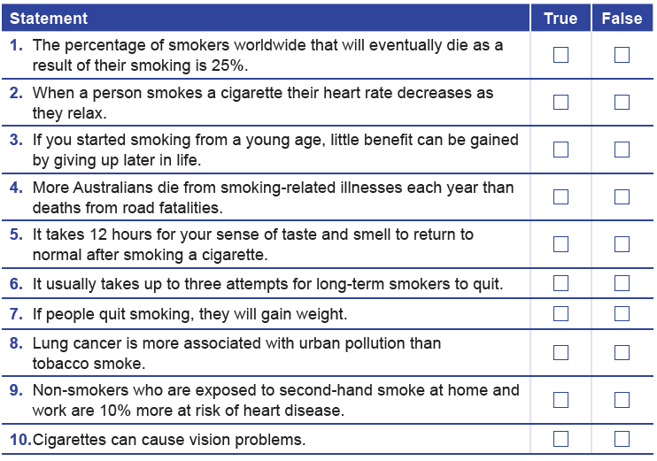

VAPING QUIZ
What did you learn?

Statement | TRUE/FALSE
1.

2.

3.

4.

5.

6.

7.

8.

9.

10.

